Problem statement. – Upload any image the content need to be recognize. Like floor plan, or anything.

Solution – The problem can be solved by using following 2 approaches.

**Approach 1 – (Using Optical character recognition - to read the content of image) using html and JavaScript***Please note: faced some issue with image quality so I have used following mentioned image.*

1. Find the image content like text, number and its coordinates i.e., x0,y0 and x1,y1.
2. Taken help of Javascript library “tesseract.js” – which will read the image and provide the object array like Number of words and its Respective coordinates. <https://cdn.rawgit.com/naptha/tesseract.js/1.0.10/dist/tesseract.js>
3. Display the image simply by using image tag.
4. Then create a html map for the image.
5. Create a javascript function which will create a html area for the map based on collection of text / number which are on images. Or we can also consider the circle, rectangle object.
6. Apply hyperlink / alter on image. i.e., we can get click event form where we can pass information to any other method or to API.

**Result:**

**Input param image**

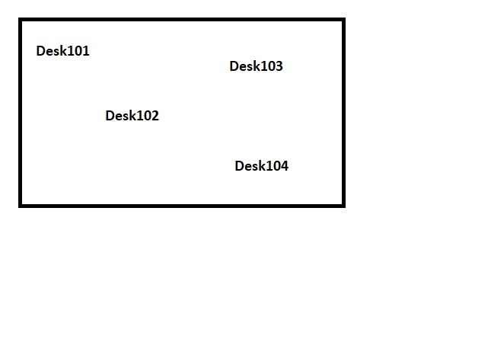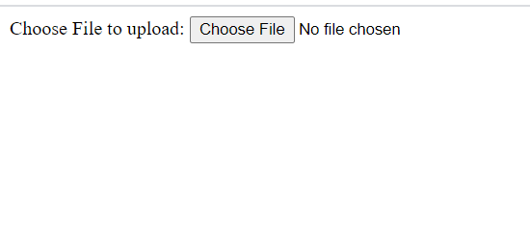

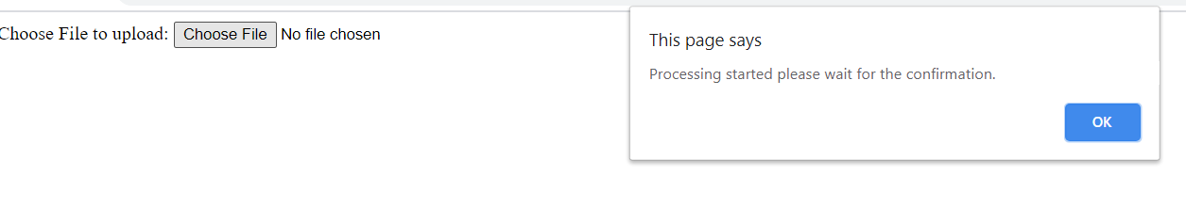

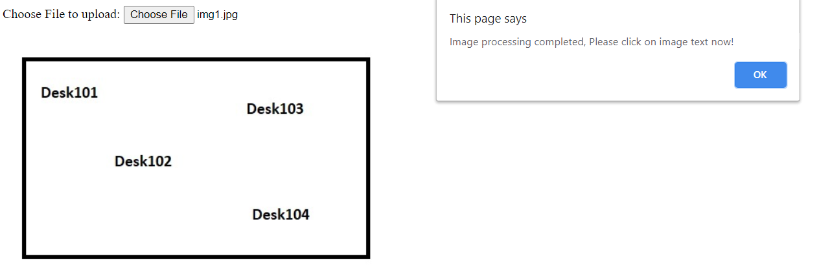

**Now user can click on the image text which will be now hyperlink.**

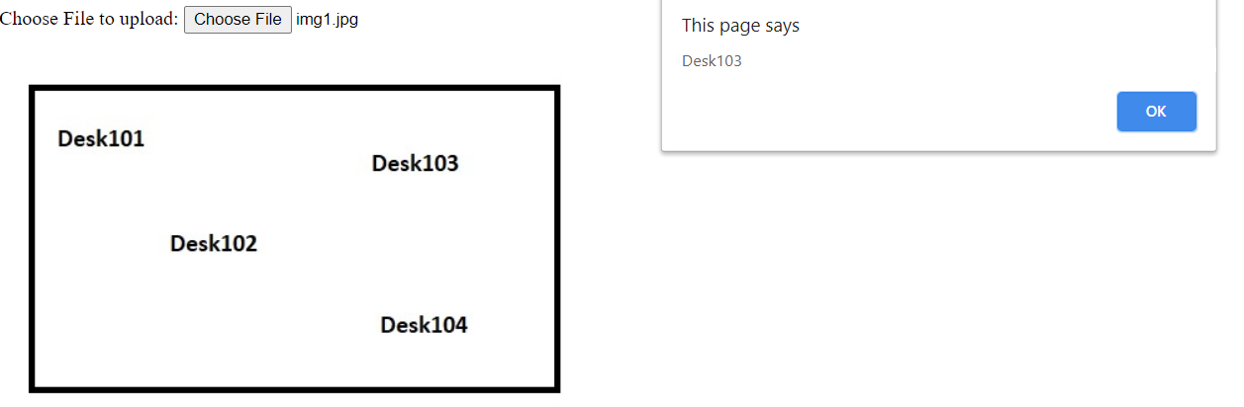

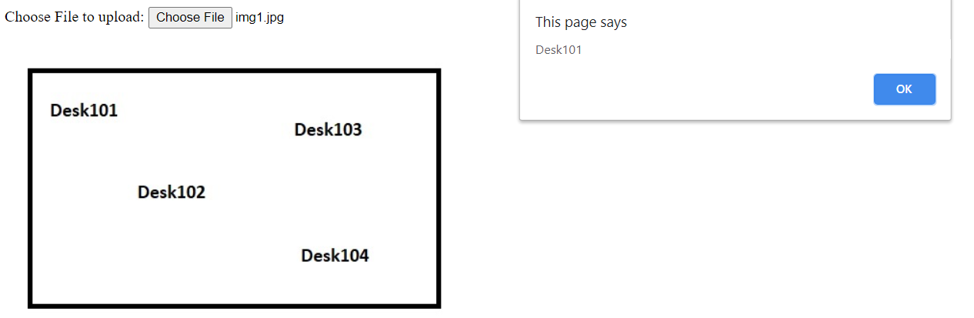

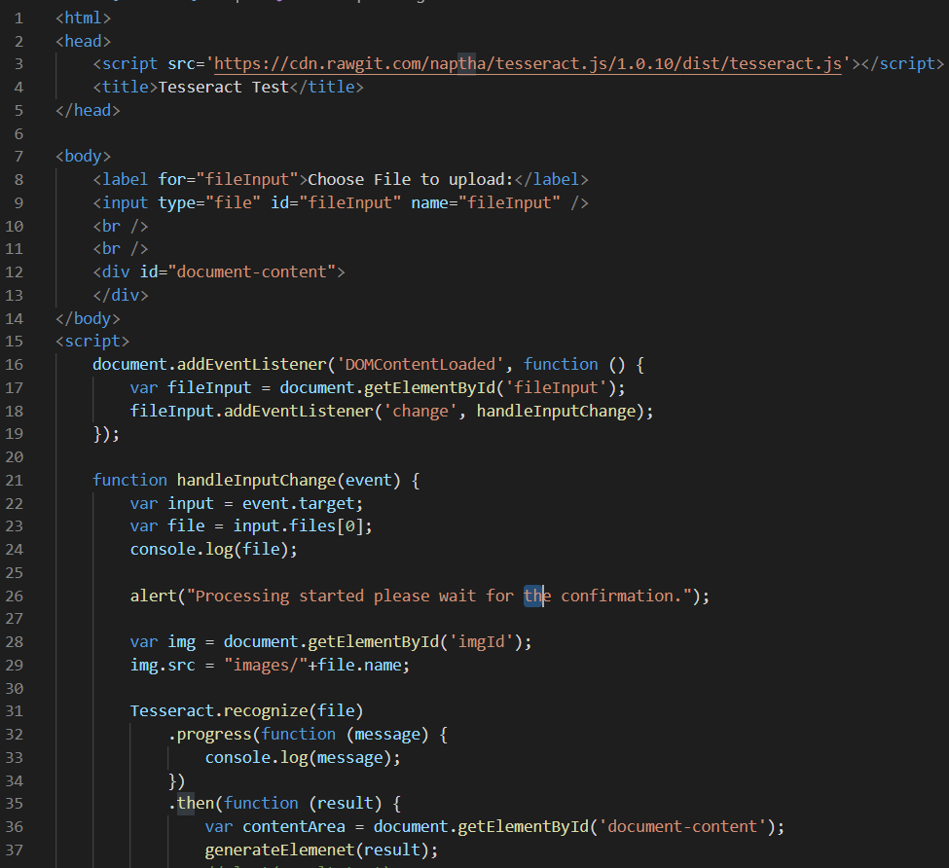

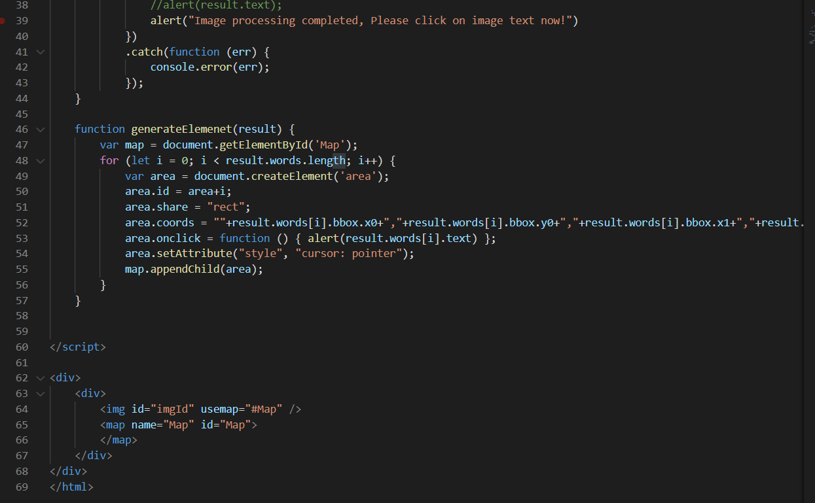

**Approach 2 : SVC – Scalable Vector Graphics**It’s a xml based format to draw images. Many online tools are available which can convert any image to SVG file. We can get all the patterns, shapes, link box and coordinates its clickable area, mouse over, i.e., all possible event.

Steps will be.  
1. Upload a file.

2. Convert the image png, jpg to svg file.

3. Apply the require events on xml attributes on svg file so every require object consider.

4. Call the method or API based to pass information to server.